Lab 5: FIRST PRINCIPLES MODELING

EEE4514

Marcel 1, 2017

**Gabriel Stroe**

# Filtering

## Overview

The purpose of this lab is to create a second order system that is underdamped. This system should ramp up the servo motor and cause it to overshoot its target voltage by a set amount. We will also take a look at the natural frequency and the dampening ratio of the system as well as calculate the peak time and percent overshoot.

## Theory and Methods

The base form for a second order system is as follows:

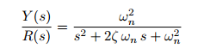

Where ω is the natural frequency and ξ is the damping ratio. To find these values we are given that the general servo motor transfer function is as follows:

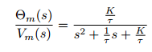

From here we are given that K is 23 rads/Vs and T is 0.13. Using that we can calculate ω and ξ. Below are the values listed from our system. Mp and Tp can be calculated from the natural frequency and the dampening ratio.

|  |  |
| --- | --- |
| Item | Value |
| K | 23 |
| T | 0.13 |
| ω | 13.301 |
| ξ | 0.289 |
| Mp | 0.387 |
| Tp | 0.28 |

## Results

As you can see from the chart below the results are only slightly off. The Y value represents the peak overshoot which is 0.34 (subtract 1 from 1.34 to find how much the overshoot is), slightly less than the 0.38 that we calculated. Also looking at X axis, the peak overshoot time is 0.24 (again subtract 1 from 1.24 to remove the start time) which is slightly smaller than the calculated value of 0.28. This error is most likely do to the mechanical ware on the servo motor that occurs overtime. The relative proportionality of the overshoot and time I believe indicate that this is the case even further. Also it is possible that the documents estimation of K and T are slightly off.

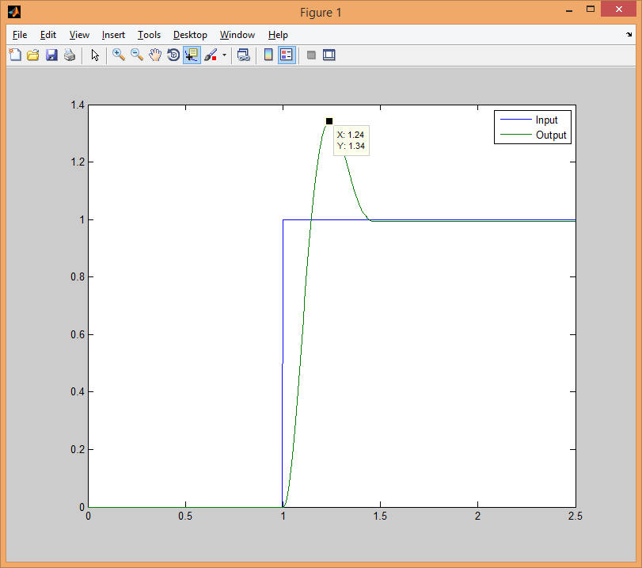

## Questions

1. Mp = 0.38 Tp = 0.28

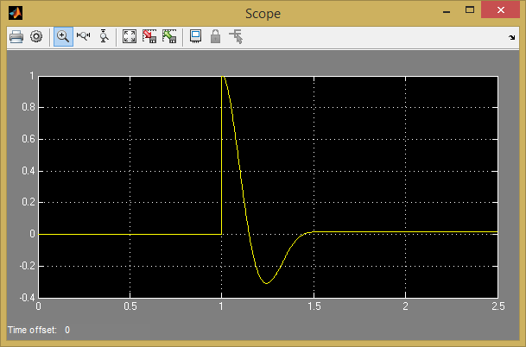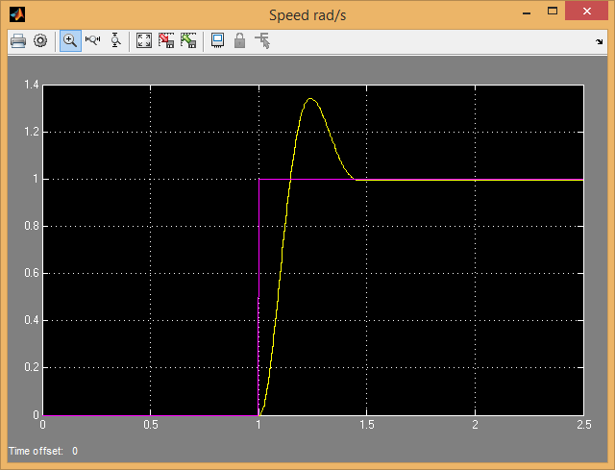

## Conclusions

From this lab we have learned that how to take some base values of the servo motor and use them to calculate other components to model the system. In this case we were able to use the steady state gain and model time constant to get the peak overshoot and peak time. For our case we were slightly off, which is most likely do to the difference from the given values to the actual steady state gain and time constant.